1 Introduction

1.1 Luego Sports Cars Ltd

Luego Sports Cars Ltd has been involved in the motor sports industry for a number of years. They have produced work for Champion Motor Company (CMC) Spain, Tiger Racing, CMC USA, Ron Champion, and Locost ltd.

1.2 Aims of Project

The purpose of this thesis is:
- To perform a torsion test on the prototype chassis to determine its torsional stiffness;
- To create a finite element model of the chassis;
- To incorporate a design improvement study and note the effects on the global torsional stiffness of the chassis;
- To attempt an optimisation for maximum efficiency.
The following limitations are given for this project:
- The body shape is fixed and therefore the overall external shape of the chassis must not be altered;
- The engine bay must remain as open as possible to allow a variety of engines to be fitted;
- Complex assemblies are to be avoided, as Luego is a small manufacturer.

2 Definition of a Chassis and Required Properties

2.1 Definition of a Chassis

The chassis is the framework to which everything is attached in a vehicle. In a modern vehicle, it is expected to fulfil the following functions:
- Provide mounting points for the suspensions, the steering mechanism, the engine and gearbox, the final drive, the fuel tank and the seating for the occupants;
- Provide rigidity for accurate handling;
- Protect the occupants against external impact.

While fulfilling these functions, the chassis should be light enough to reduce inertia and offer satisfactory performance. It should also be tough enough to resist fatigue loads that are produced due to the interaction between the driver, the engine and power transmission and the road.

4 Calculation of the Global Torsional Stiffness

The torsional stiffness of a chassis is determined from the twist angle between the front and rear axles under a torsional load, either static or dynamic.
The static load occurs when the chassis is stationary and one corner is elevated, for example under jacking conditions. The forces on the four corners impose a twist torque on the chassis.
The dynamic load occurs when the chassis is moving, for example, when a wheel travels over a bump. The force applied by the bump travels through the wheel and tyre into the coil-over and is applied to the coil-over mounting points. This also causes the chassis to twist.
The static load has been chosen for this project as it can be easily replicated for the testing and modelling of the chassis. A load is applied to the coil-over mounting points and the torsional stiffness of the chassis can be easily determined.
The torque applied to the chassis is a function of the force acting on the coil-over mounting points and the distance between the two front or rear coil-over mounting points.
F
L
M_{T}
BUMP

Fig. 18

The global twist angle of the chassis is the function of the vertical displacement between the two involved coil-over mounting points and their distance.

L_{width}
Δ_{L}
Δ_{R}
L_{width}
Δ_{L} - Δ_{R}
Δ_{R}
Δ_{L}

Fig. 19

θ_{twist} = arc tan {(Δ_{L} - Δ_{R}) / L_{width}} deg

The torsional stiffness of the chassis can be obtained:

M_{T} = ƒ dM_{T} = K_{T} x θ_{twist}

⇒ K_{T} = M_{T} / θ_{twist} [Nm/deg]

The equation above describes the torsional stiffness of the chassis as ‘the torque required to generate one degree of chassis twist angle.’

5 Description of Prototype Chassis

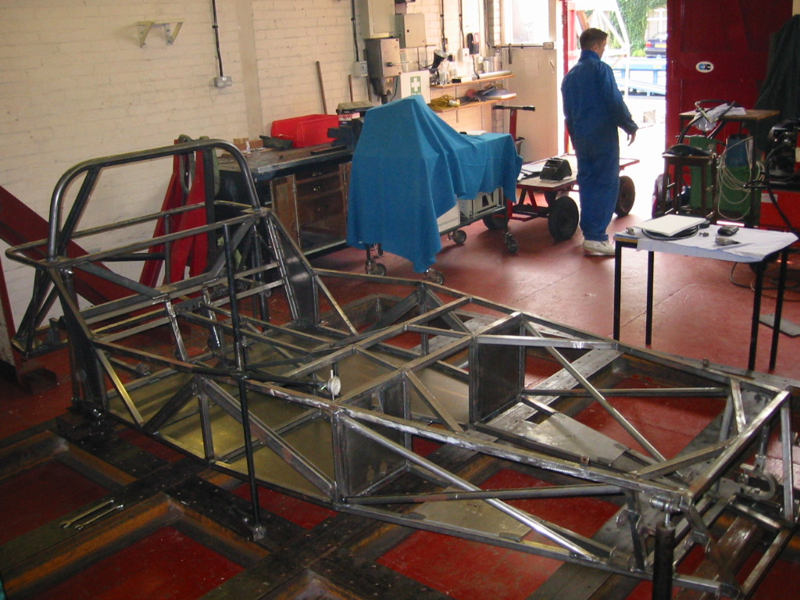

Fig. 20

The prototype chassis supplied by Luego is shown in Fig.20 and is described as a spaceframe chassis. It is constructed from mild steel Rectangular Hollow Section (RHS) and tubing with sections of mild steel sheet. The majority of the RHS is 1” x 1” (25.5 x 25.5mm) with a gauge size of 16, equivalent to a 1.6mm wall thickness. The transmission tunnel frame is ¾” x ¾” (20 x 20mm) and the side impact bars in the passenger compartment of 2” x 1” (51 x 25.5mm). The tubes are of 1” diameter 16-gauge for the engine bay and rear framework and 2” diameter 3mm wall thickness for the roll bar.
The floors and footwells are 16-gauge sheet with the side panels, roll bar mounts, gearbox plate and engine plates of 3mm sheet. There are also sections of 5mm thick bar and 8mm thick bar.
It is designed to carry two occupants either side of the transmission tunnel. Many of the load paths feed directly into the transmission tunnel effectively using it as a backbone. These loads are therefore carried by the smaller diameter RHS beams. The transmission tunnel is triangulated on either side to protect the occupants in the case of a prop-shaft break through however; it is not triangulated on the top or bottom leaving it as an open section. (Fig. 21)
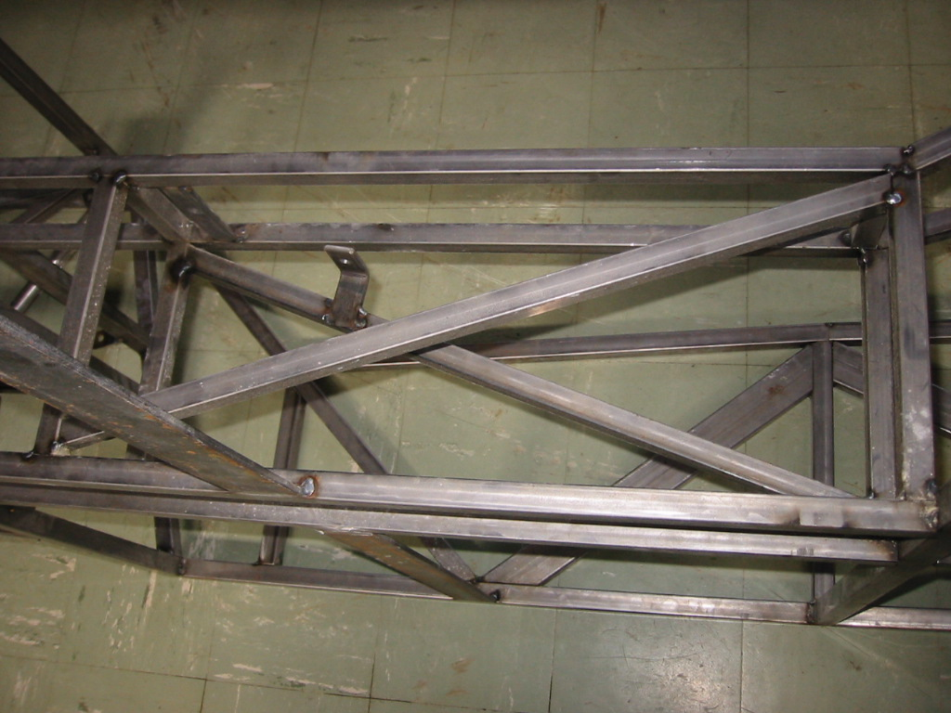
Fig. 21

The engine bay is a large open structure as can be seen in Fig. 22

Fig. 22

The tubes in the engine bay bypass each other without connecting and no triangulation is provided laterally.
Even though the footwells have shear panels the transmission tunnel is still open and free to lozenge with no support present on the bottom section of the opening due to the need for clearance of the transmission. The suspension box in front of the engine bay is also completely untriangulated and free to lozenge. With the suspension loads being applied to this region the deformation will be most severe in this area and the engine bay.
The passenger compartment forms a large open bay. If we compare it with the simple example of a matchbox without the cover, it is clear that it is much more easily deformable than a matchbox with the cover on. This is because it is an open bay. The cover provides a shear panel in every direction. This is effectively what happens in the passenger compartment. If this open area can be reduced then we will see an improvement in the stiffness.
The rear area of the chassis is again relatively untriangulated however, the suspension loads are fed into the large and substantial roll bar structure as shown in Fig. 23 affording much more torsional stiffness than the engine bay and suspension box areas.

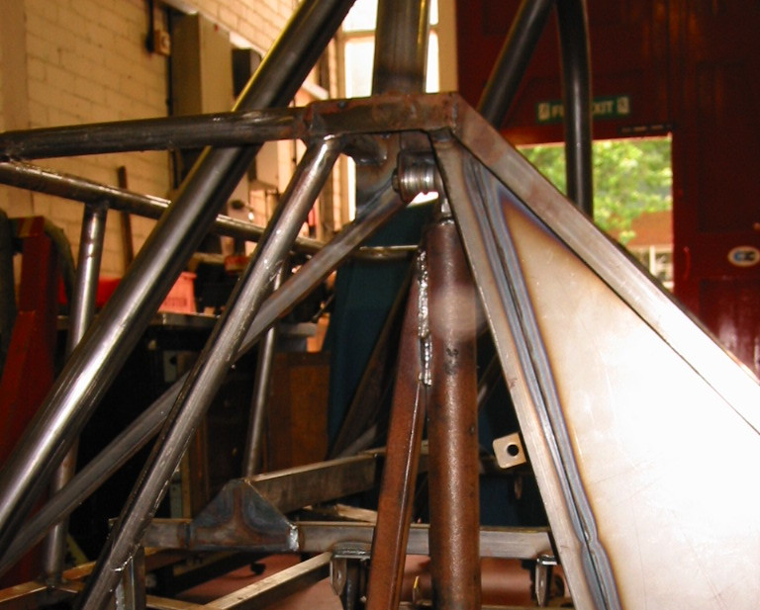

Fig. 23

Table 1 Section Dimensions

Name | Dimension | Thickness | Type
Main Rails Top | 1” x 1” | 16-gauge | RHS
Main Rails Bottom | 1” x 1” | 16-gauge | RHS
Main Verticals | 1” x 1” | 16-gauge | RHS
Transmission Rails | ¾” x ¾” | 16-gauge | RHS
Tubes | 1” ∅ | 16-gauge | Tube
Rollbar | 2” ∅ | 3mm wall | Tube
Bar | - | 5mm & 8mm x50mm | Bar
Sheet | - | 16-gauge & 3mm | Sheet

Material Properties

Mild Steel:
Young’s Modulus 210Gpa
Shear Modulus 80GPa
Density 7810 Kg/m³

Aluminium:
Young’s Modulus 71GPa
Shear Modulus 26.2GPa
Density 2710 Kg/m³

6 Physical Testing of the Chassis

The chassis supplied by Luego was tested on a torsion rig to determine its torsional stiffness.
The suspension planned for the chassis is of the coil-spring over damper variety. This implies all loads will be applied through these mounting points. The coil-over mounts were therefore used for the constraints and load.
An object always has six equations of equilibrium, three force equations and three moment equations. In order to achieve a statically determinate system, six forces must then be applied. As can be seen in Fig.24 this was accomplished by restraining three of the coil over suspension mounts of the chassis and applying a load to the free suspension mount. If more than six restraints are employed the structure becomes statically indeterminate making the chassis appear stiffer than it is. The deflection was measured along the length of the chassis on both sides with dial test indicators and the global torsional stiffness calculated as described in chapter 4.

LOAD
Rx
Ry
Rz
Ry
Rz
Rz

Fig. 24
Many torsion figures claimed by manufacturers for vehicles are arrived at while using torsion rigs with seven or more restraints causing the over constraint as described above, i.e. the chassis is fully restrained on both rear corners and at one front corner.
Fig. 25 shows the left rear restraint. The restraint is mounted to the chassis suspension mounting points with ball joints to prevent any moments being applied. The gaps between the ball joints and the suspension mounts are filled with spacers to prevent movement.
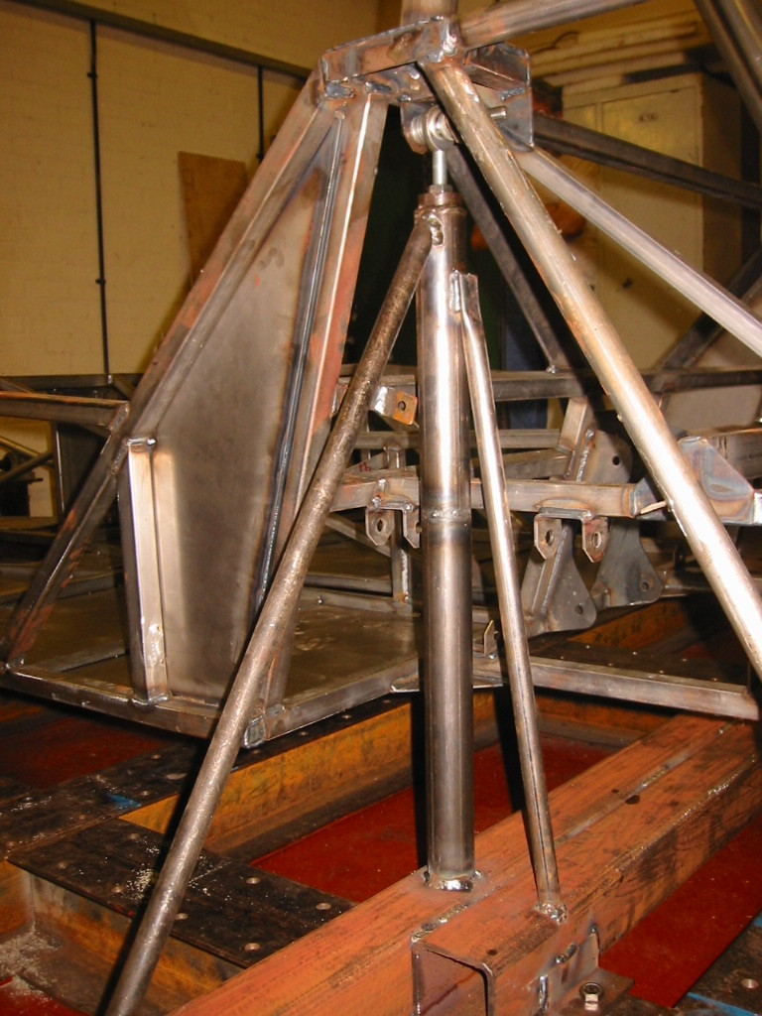

Fig.25

The load was measured with a Horseshoe Dynamometer as shown in Fig. 26 and applied with a turnbuckle. The chassis was preloaded with the turnbuckle before any load and deflection measurements were taken to take up any slack in the rig.
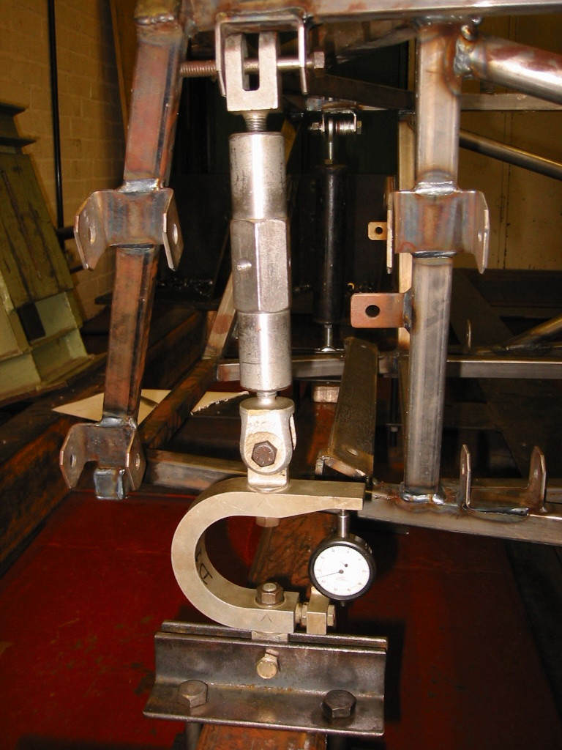

Fig. 26

Fig. 27 shows the deflection measurement points on the chassis.

8
7
1
5
6
3
4
2

Fig. 27 Dial Test Indicator measurement positions

1 – Front left suspension mount
2 – Front right suspension mount
3 – Left footwell bulkhead
4 – Right footwell bulkhead
5 – Left mid-passenger compartment
6 – Right mid-passenger compartment
7 – Left rear suspension mount
8 – Right rear suspension mount

From the measurements the Global torsional stiffness K = 1330 Nm/Deg

FE Modelling Description and Validation of Baseline Model

7.1 FE Model

To begin the Finite Element analysis a model of the chassis must be created. This was achieved using the universities Patran/Nastran FE modeller/solver software. It was decided to create a line model of the prototype chassis. This type of model is not a dimensionally or geometrically perfect copy of the prototype but a simple representation of it. This was chosen to facilitate relatively simple modification of the baseline model for the improvement study. The results are not intended to be 100% accurate but are intended to give an indication of the stiffness achievable and the effects each of the modifications has.

7.2 Patran/Nastran

The finite element analysis software used is the Patran/Nastran geometric and solver package developed by MSC [Ref. 6]. Patran is the geometric section where a line model representative of the chassis is created. The geometry (cross sectional area A; 2nd moment of inertia Ix, Iy; torsion constant J), element type, load cases and application regions, material properties (Young’s modulus E; shear modulus G; Poisson’s ratio μ; density kg/m³) and basic analysis are selected and created. The Nastran solver can then be employed for the full analysis of the structure. The output file is then read back into Patran for viewing the results.
The geometry is modelled in 3D with point-to-point lines representing the beams and tubes and their intersections. Surfaces are also created in this way with either points or lines representing surface vertices or edges. The element type can then be selected and a mesh applied to all beams and surfaces. The element types selected were the Beam element for all beams and tubes, and the shell element for all surfaces.

7.2.1 Bar element

The RBAR element is a beam element that supports tension, compression, torsion, bending and shear in two perpendicular planes. It connects two nodes and provides stiffness to all six degrees of freedom in each end. Its gravity axis, elastic axis and its shear centre are all coincident [Ref. 6].

7.2.2 Shell element

The shell element chosen for modelling surfaces and panels was the QUAD4 element. This is a 2-dimensional shell element that can represent in-plane bending and transverse shear behaviour. This means it only has five degrees of freedom at the nodes, the rotational degree of freedom perpendicular to the element is unconnected and must be given an artificial stiffness. This is performed in Patran by setting the K6ROT – parameter to a greater than zero value [Ref. 6].

7.3 Model correction

A number of models were created, as the stiffness value necessary was not being obtained. Upon analysis of these models, it was found that some of the geometry of the engine bay was incorrect. This was modified but the stiffness value was still not in the region of the physical test result further analysis of the model was required. After thorough examination of the model, it was discovered that the main engine bay top rails were not connected to the front suspension box. With this corrected the model achieved a stiffness value of 1352.33 Nm/deg.

The model should not be expected to give completely accurate results when comparing with a torsion test of the real chassis, as certain simplifications may be influential:
- Offset connection of two tubes, leading to local bending is not included in the model.
- Varying material thickness due to welds, etc. has not been taken into consideration.
- A finite element model assumes that joints are infinitely stiff, which is incorrect.
- The suspension mounts are approximate to the actual shape and exact location.
These factors should lead to the model being slightly stiffer than the test result as has been found with this model.

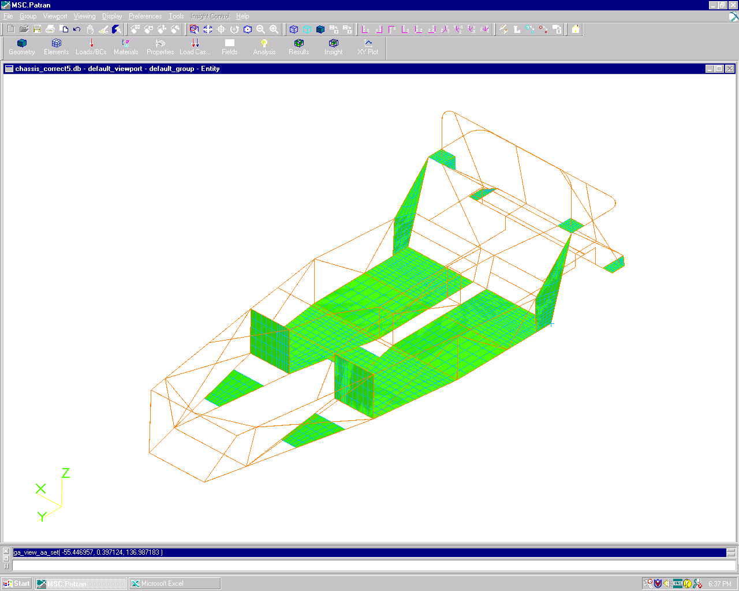
7.4 Final Validation of Baseline Model
Engine plates
Gearbox plate
Footwells and floor
Side plates
Roll bar plates

Fig. 28

Table 2

This model [Fig. 28] represents the prototype chassis as supplied by Luego for physical testing.
All modifications were made to this model to ensure as accurate a stiffness value as possible. The areas highlighted in green are mild steel panels. The engine plates, gearbox plates, roll bar plates and rear side plates are all 3mm thick with the remaining floor panels and footwells 1.6mm thick.
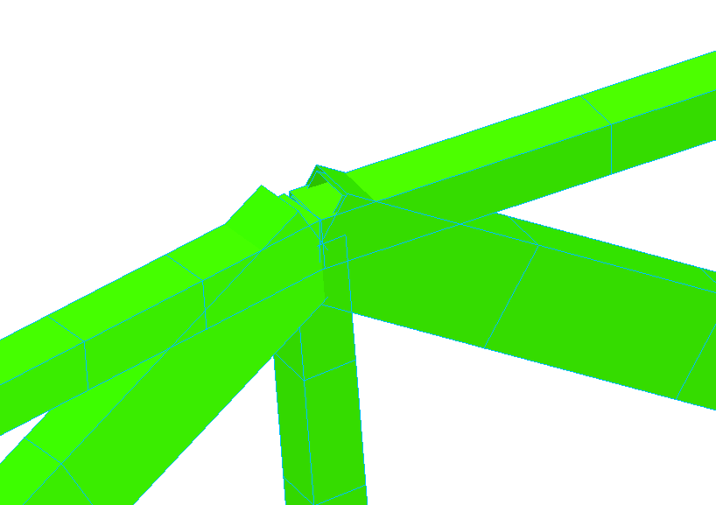
The mass of the model is higher than the physical chassis due to a number of factors. The modelling software does not take into account that material is removed from each beam where it joins another, i.e. at every joint the software assumes that the material from each beam is present so for a joint with four connecting beams there will be material from each beam at the same point. The software also extends the material of angled beams past their end-points on the chassis. As previously mentioned the model is also not an exact geometrical copy. This material will add up to give the excess mass. These phenomena can be seen in Fig. 29 below.

Fig. 29

Design Improvement Study

8.1 Stage 1 – Discussed Modifications

After initial appraisal of the chassis, a number of areas were discussed with Luego for improvement after they had suggested areas they were reconsidering for ease of construction. The inclusion of the riveted and bonded steel transmission tunnel panels and rear wall, and the aluminium side panels will also be modelled. The percentage increases shown in the tables below are increases non-inclusive of the original values given in Table 2.
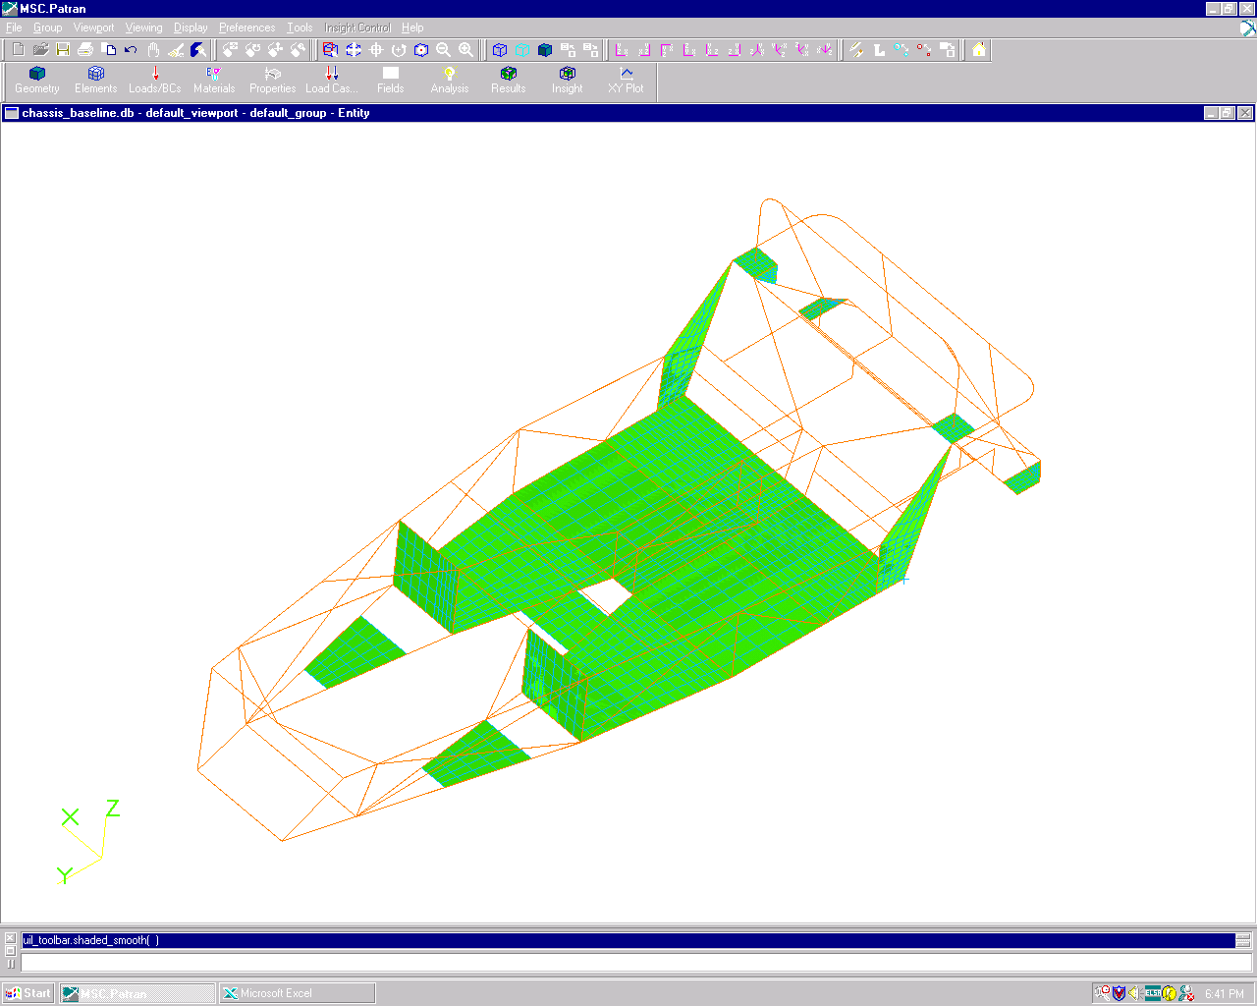

8.1.1 One- piece floor
Fig. 30

Table 3
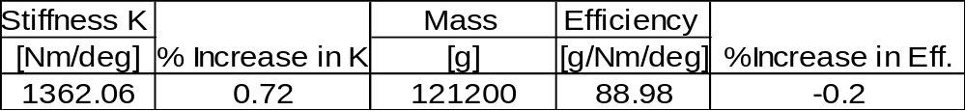
As mentioned in chapter 5 the transmission tunnel is an open section. As a first step, the floor can be made from one continuous panel, strengthening the backbone feature of the transmission tunnel by closing this section.

8.1.2 Transmission tunnel panelled

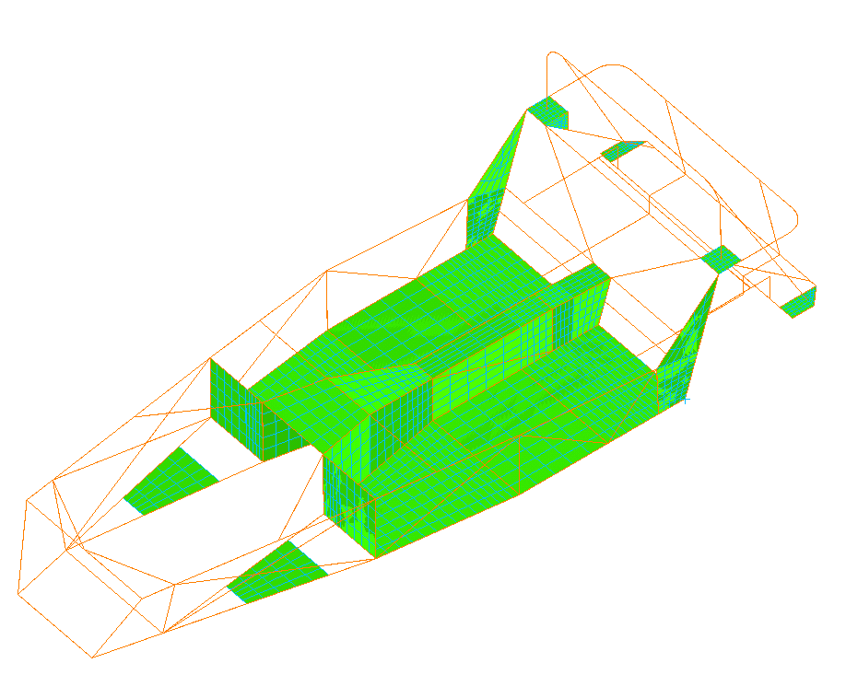
Transmission tunnel panels

Fig 32

Table 4
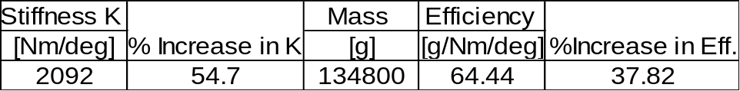

With the replacement of the two-piece floor with a one-piece item and the panelling of the transmission tunnel [Fig. 32] a backbone is formed. With this now being closed along the majority of its length it acts as a torque tube. The improvement to the torsional stiffness can clearly be seen in table 4 with a 37.82 % increase. These panels are mild steel of 1.6mm thickness.

8.1.3 Cross bracing of engine bay tubes
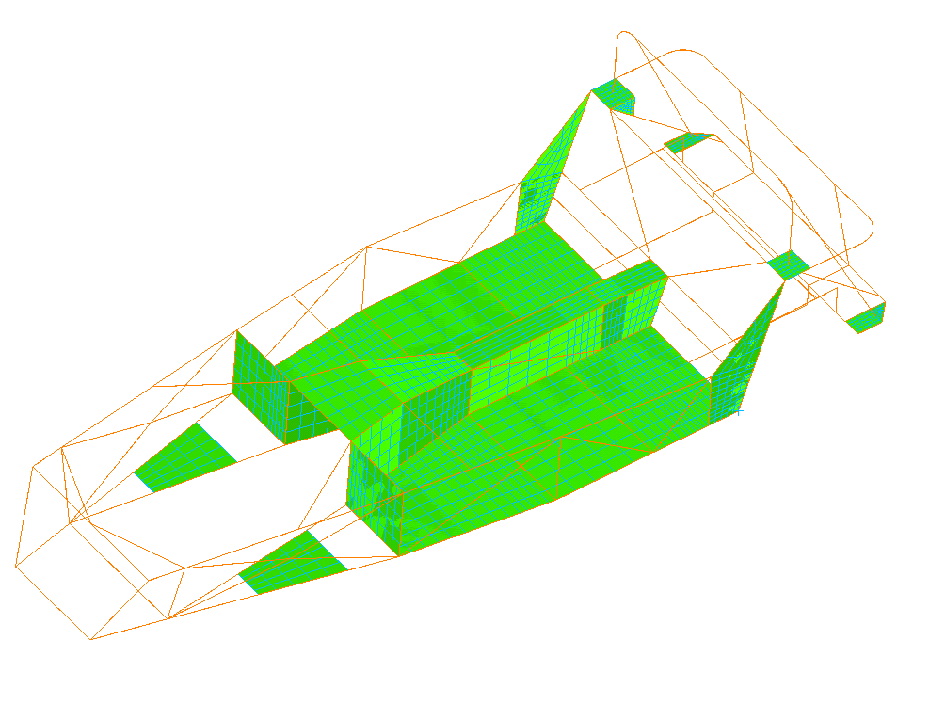
X-Brace

Fig. 33

Table 5
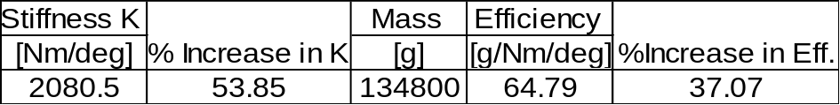

The round tubes in the engine bay sides merely bypass each other without touching. By splitting these tubes and forming an X-brace [Fig. 33] the torsional stiffness decreases slightly from the previous model, however this modification will allow more clearance for the aluminium side panels to be fitted by Luego. The drop in torsional stiffness and efficiency is not large enough to warrant any concern and this modification may be unavoidable.

8.1.4 Addition of rear firewall
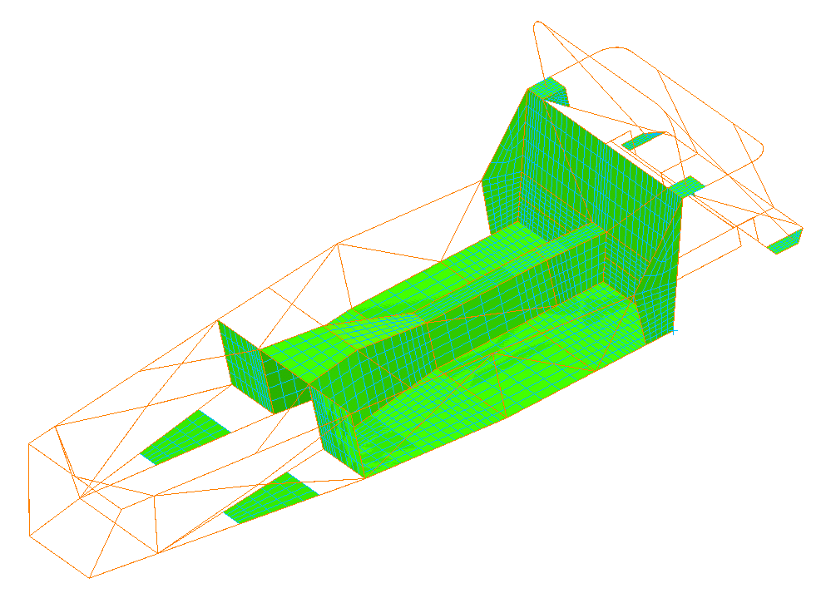
Rear Firewall

Fig. 34

Table 5
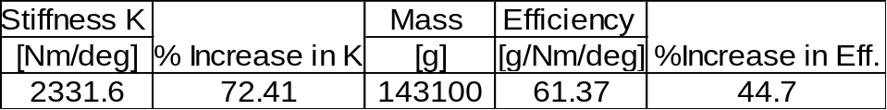

As shown in Fig.34 and Table 5 the rear firewall forms a large shear panel across the rear bulkhead. The torsional stiffness is increased once again by almost 20% over the previous model. The efficiency has also improved by approximately 7% over the previous model. This shows that the some of the loads are being taken up by this rear firewall. This is to be expected, as the framework to which it is attached is a major load-carrying bulkhead taking the load of the rear suspension mounts. The panel helps prevent lozenging of this bulkhead. This firewall is a mild steel panel of 1.6mm thickness.

8.1.5 Addition of bar across dash area
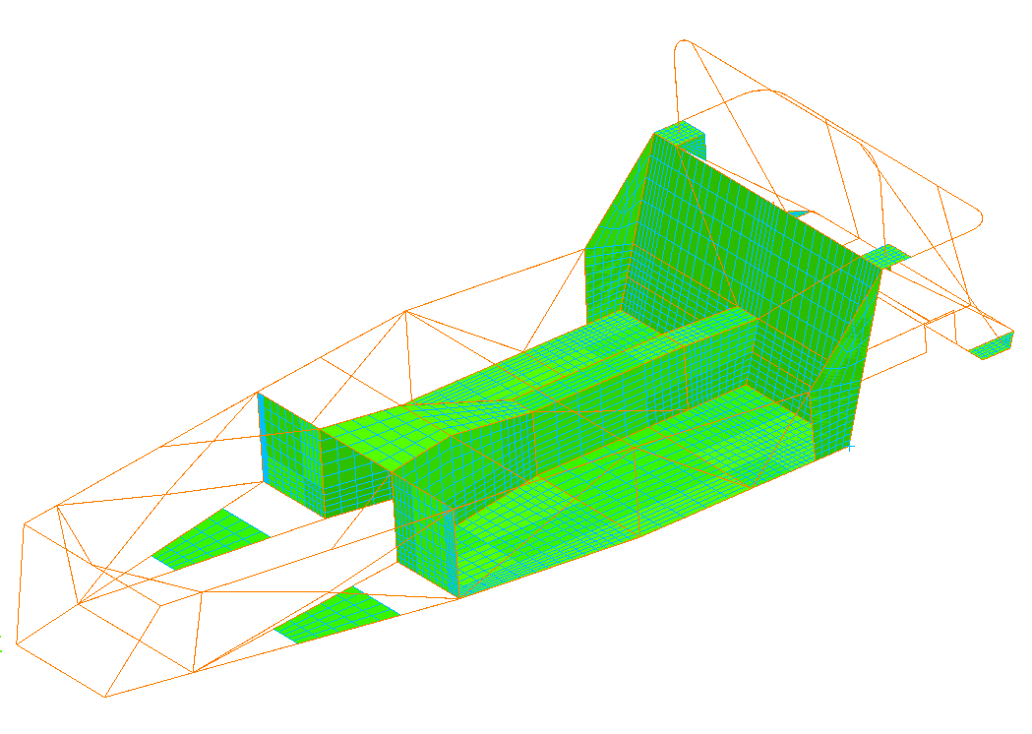
Dash Bar

Fig. 35

Table 6
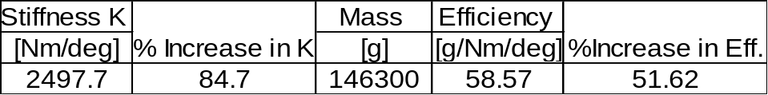

Analysis of the deformed model showed that the main rails were being pulled apart under loading. The dash bar ties the two upper side rails together and forms another box to which further enhancements can be made. A 12% increase in stiffness can be seen over the previous model with the efficiency improving by 7%. Luego plan to use this to mount the scuttle panel. The bar is a 2” x 1” 16-guage RHS mounted with the 2” section dimension horizontal to be most effective in the plane of twist this section is exposed to.

8.1.6 Panelled dash bar and footwell tops
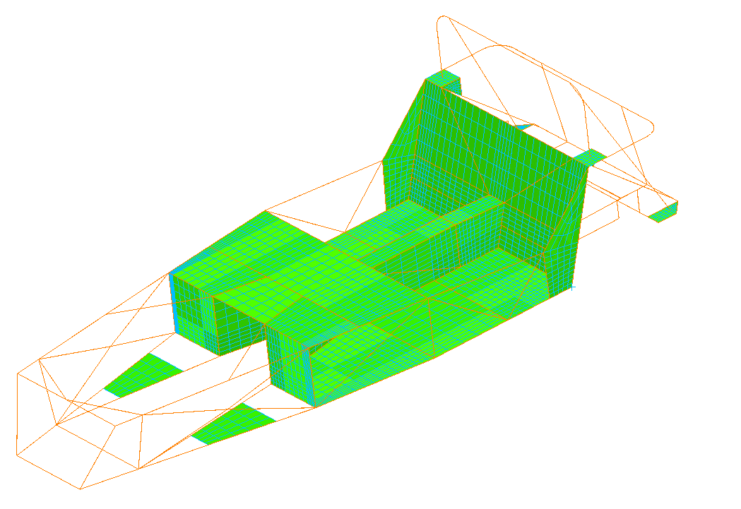

Fig. 36

Table 7
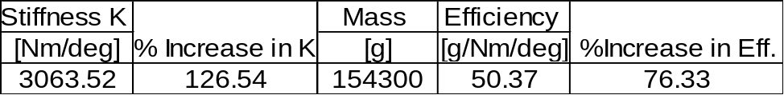

As can clearly be seen in Table 7 reducing the open section of the passenger compartment by the panelling of the dash bar area and footwell tops considerably increases the torsional stiffness of this area. This section is already relatively stiff in comparison to the open and untriangulated engine bay yet this modification sees an improvement to the torsional stiffness of over 40% on the previous model. The panelling creates a shear panel across this section, which closes part of a face of the open torsion box created by the passenger compartment. This modification is also realised in the increase in the efficiency of the chassis with a rise of 20% over the previous model and a 76% increase over the original design. The panels are mild steel of 1.6mm thickness.

8.1.7 Addition of aluminium side panels to passenger compartment
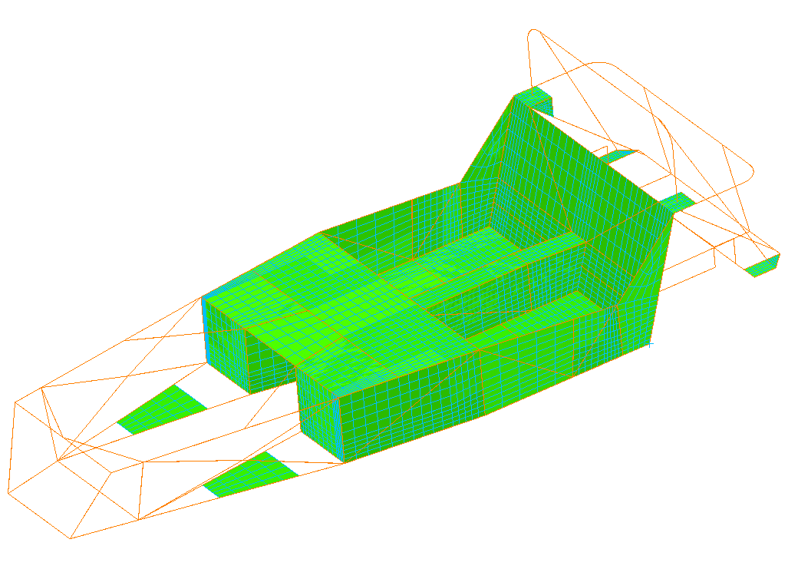

Fig. 37

Table 8
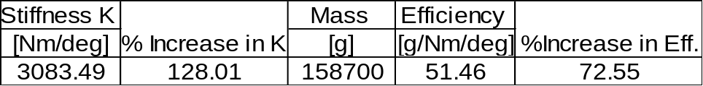

The side panels again form shear panels along the passenger compartment sides helping to further close the passenger compartment further [Fig. 37]. These panels are polished aluminium for aesthetic purposes. This proves they do however contribute to the torsional stiffness. Their contribution is small however as the efficiency of the chassis is reduced in comparison to the previous model. These panels are always fitted to the chassis’ by Luego.

8.1.8 Conversion of dash panel, transmission panels and rear wall to Aluminium
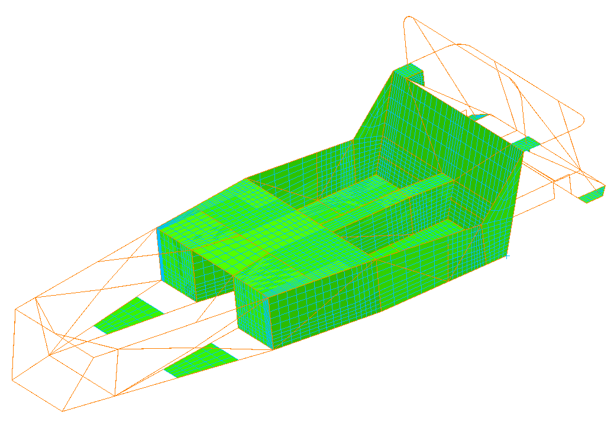

Fig. 38

Table 9
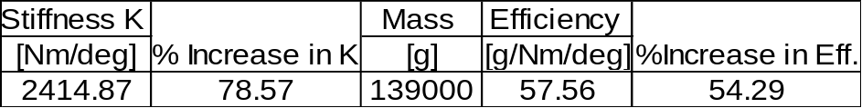

As can be seen from Table 9 changing the panels from steel of 1.6mm thickness to aluminium of the same thickness drops the stiffness quite dramatically (almost 50%). However, it does show the weight advantage of aluminium over steel as the mass is reduced by almost 20Kg. If the stiffness of the chassis can be increased without using these mild steel shear panels then the mass advantage of aluminium can be fully utilised in these areas.

Addition of Aluminium panels to engine bay sides
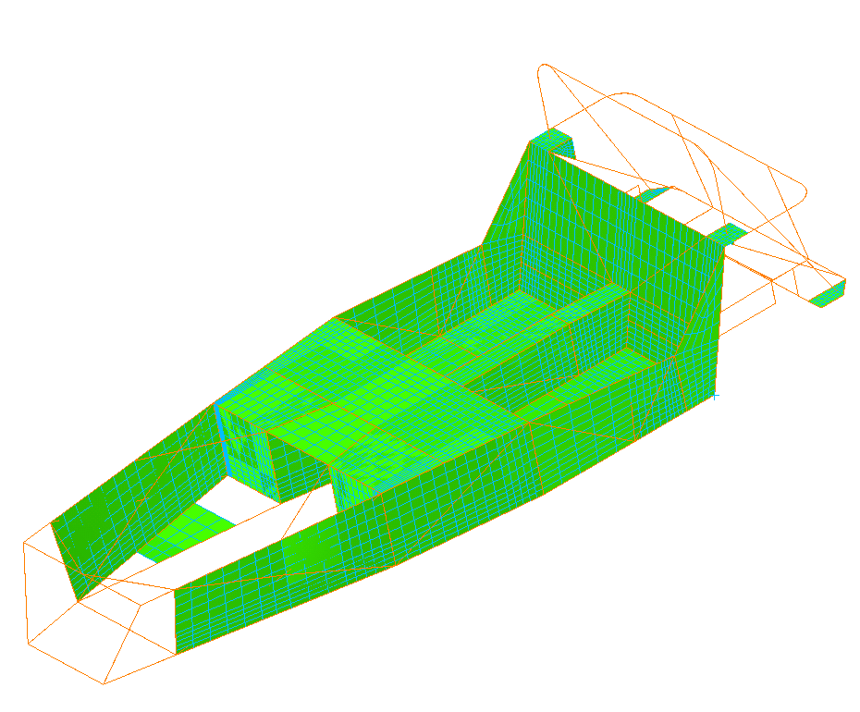

Fig. 40

Table 10
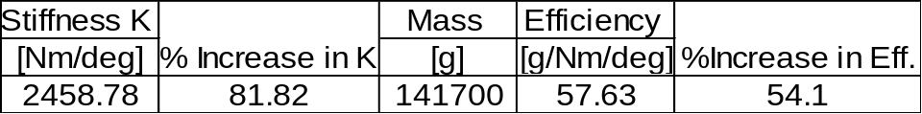

The addition of the aluminium side panels to the engine bay, which are again cosmetic, do increase the torsional stiffness. Once again however, the mass of the panels is detrimental to the efficiency. These panels are also always fitted by Luego to each chassis.

Stage 2 - Application of structures theory to bare chassis

From the calculations performed in chapter 3, it can be seen that the least stiff spring in the chassis spring system is the most predominant in the overall chassis stiffness. This means the modifications to the passenger compartment have little effect due to the flexibility inherent in the engine bay and front suspension box areas. Therefore, if any major improvements in the overall chassis stiffness are to be realised these areas must be stiffened first.

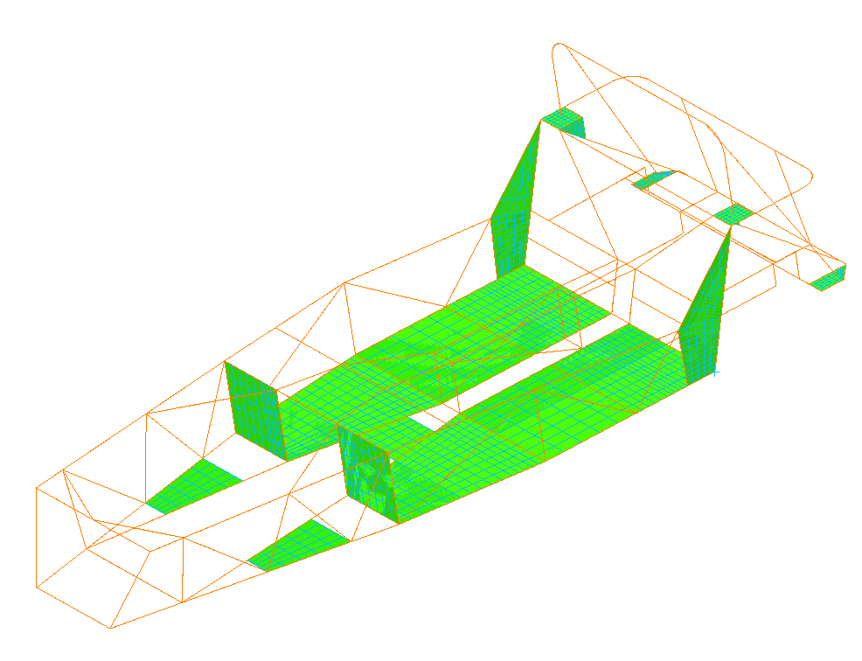
8.2.1 Conversion of X-brace to W-brace on engine bay
W-brace

Fig. 41

Table 11
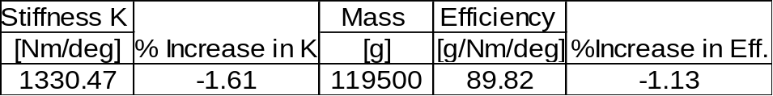

Changing the X-brace to a W-brace saves weight but lowers the stiffness. It is believed these changes will have more effect as more modifications are completed as it splits the side frames of the engine bay into four triangles.

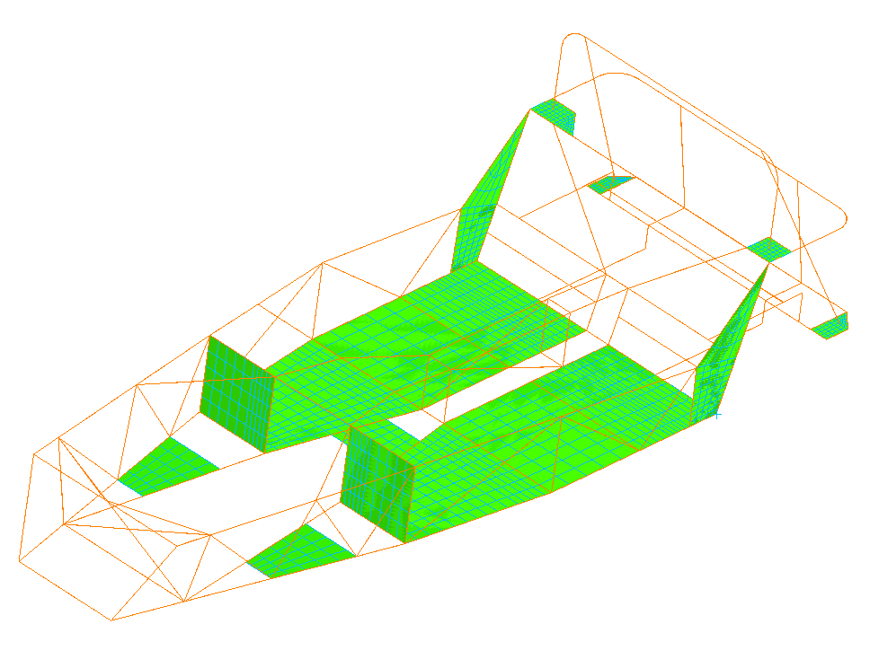
8.2.2 Addition of X-brace to front of engine bay
X-brace

Fig. 42

Table 12
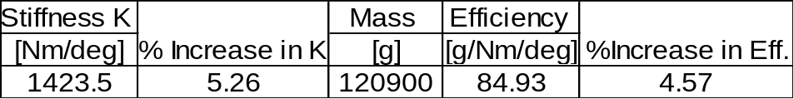

From analysis of the deformed model it can be seen that the engine bay suffers from a severe lack of lateral triangulation allowing all the boxes formed in this area to lozenge. This area is also very close to the load points of the front coil-over mounts. This modification offers an improvement of almost 7% over the previous model with almost a 6% increase in efficiency. Although these improvements seem insubstantial they provide validation the approach is working. The X-brace is constructed from 1” diameter 16-gauge mild steel tube.

8.2.3 Addition of triangulation from top of footwell bulkhead to lower main rails
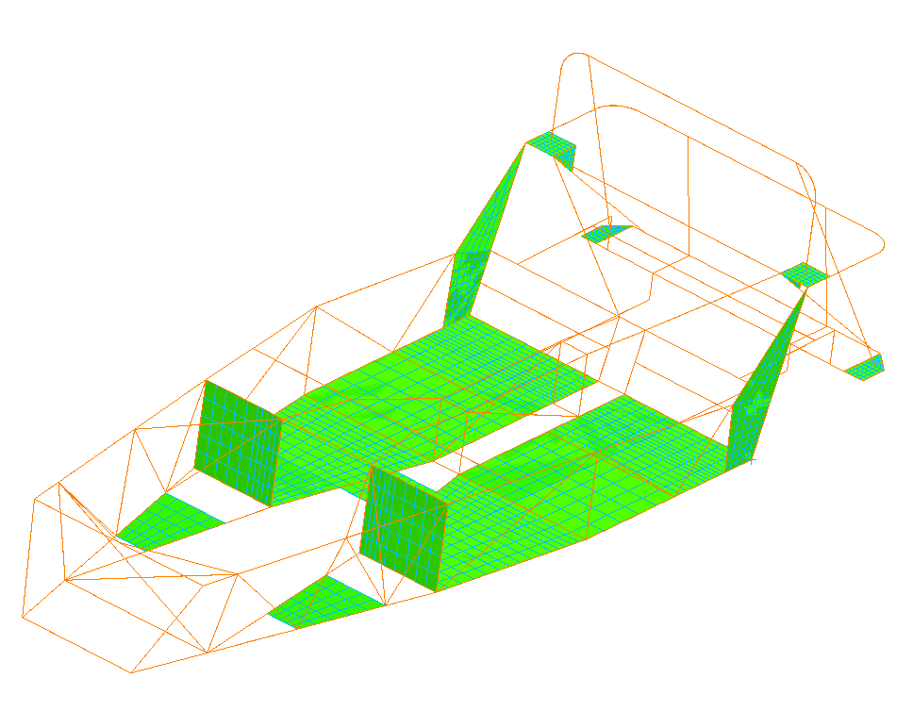
Triangulation

Fig. 43

Table 13
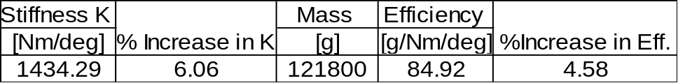

From analysis of the stress plots of the deformed model, it was observed that the top engine bay triangulation from the footwell bulkhead to the upper main rails was heavily loaded. Although not dramatically increasing the torsional stiffness, the addition of triangulation bars from the top of the footwell bulkhead to the lower main rails [Fig. 43] reduced the stress displayed by the top triangulations and marginally increased the efficiency.

8.2.4 Addition of ‘Ring Beam’ to engine bay
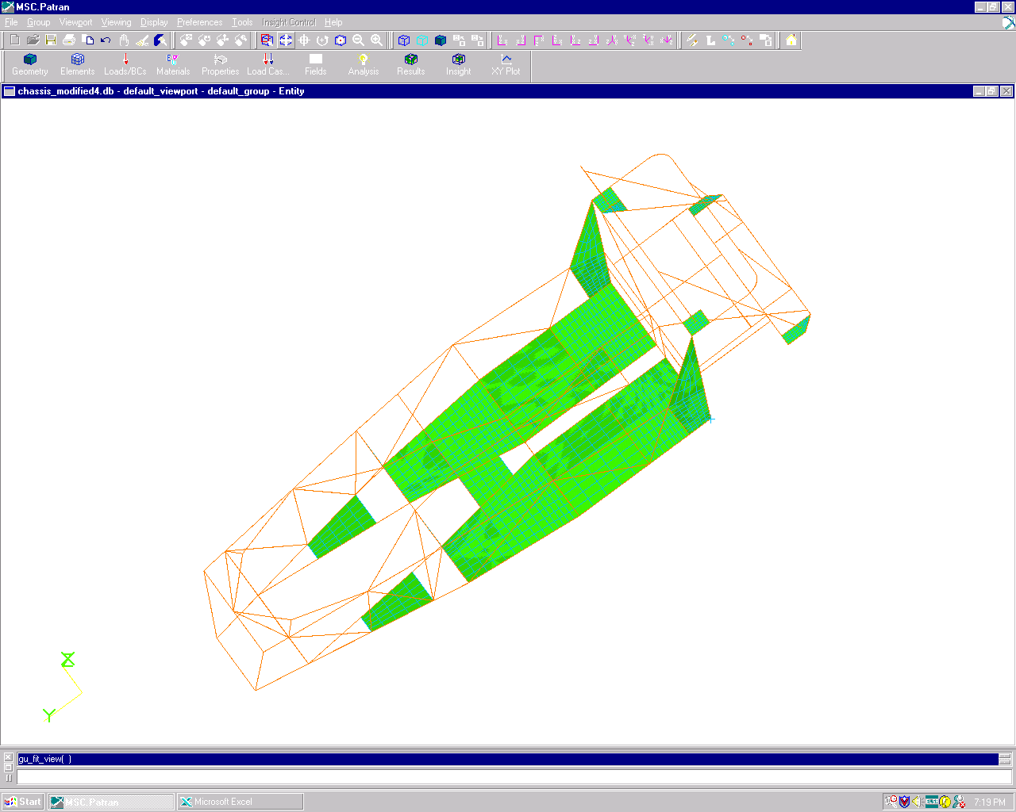
Ring Beam

Fig. 44

Table 14
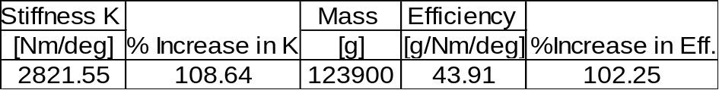

It was clear from analysis of the deformed models that stiffening needed to be concentrated on the front section and side rails of the engine bay. The rails shown in Fig. 44 form a ‘Ring Beam’ around the large opening of the upper rails of the engine bay. This transforms the engine bay into a box-like structure with triangulated surfaces with high local shear stiffness on top. This further proves that the engine bay is the least stiff spring as this relatively simple modification almost doubles the stiffness of the previous model as shown in Table 14. The increase in the efficiency shows that the chassis as a whole is absorbing much more of the load and not only relying on the transmission tunnel. The ring beam is constructed from 1” x 1” 16-gauge mild steel RHS.

8.2.5 Addition of ‘Ring Beam’ to lower engine bay
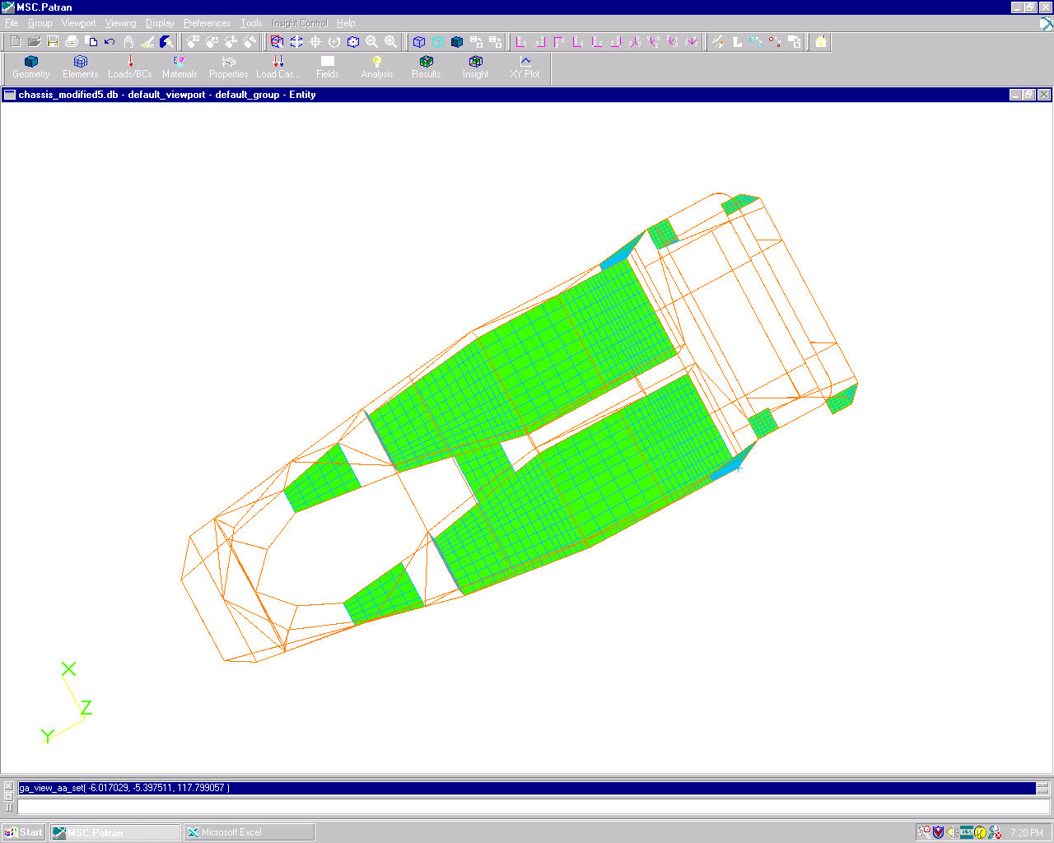
Lower ‘Ring Beam’

Fig. 45

Table 15
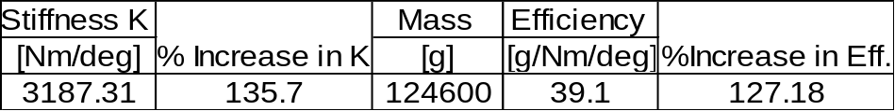

From analysis of the deformed models, it could be seen that the lower sections of the engine bay were being placed in bending. By performing a similar modification to the lower rails of the engine bay, triangulation of this area was achieved preventing the lower rails being placed in bending [Fig. 45]. With a further 28% increase in torsional stiffness over the previous model, this modification brings the overall increase to 136% over the original with a 127% increase in efficiency. Once again the ring beam is constructed from 1” x 1” 16-gauge mild steel RHS.

8.2.6 Addition of lower triangulation to the suspension box
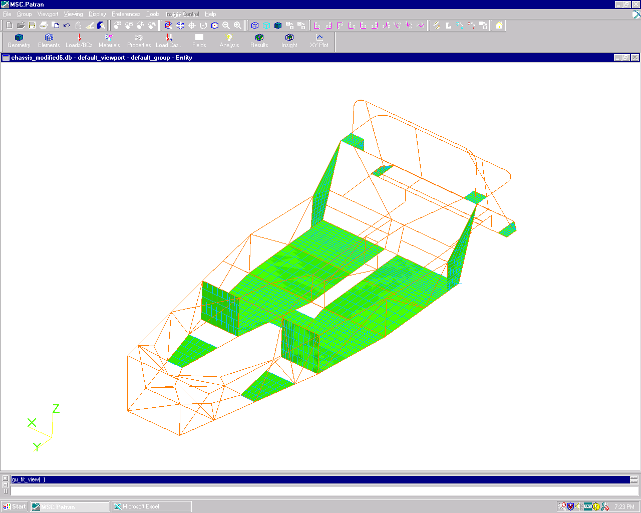
Triangulation

Fig. 46

Table 16
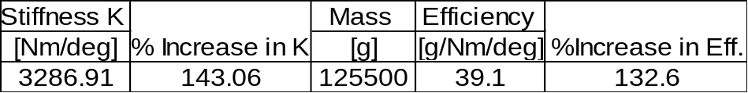

From analysis of the deformed model, the box that locates the front suspension and steering rack is almost completely untriangulated allowing lozenging that will not only affect the suspension but also the steering. Adding triangulation where possible in this box will reduce these effects. Triangulating the lower face of this box to the lower ring beam of the engine bay not only increase the torsional stiffness by 7% but will also channel the bending loads imposed on this section effectively into the lower ring beam.

8.2.7 Vertical triangulation of the upper ring beam to the lower frame rails
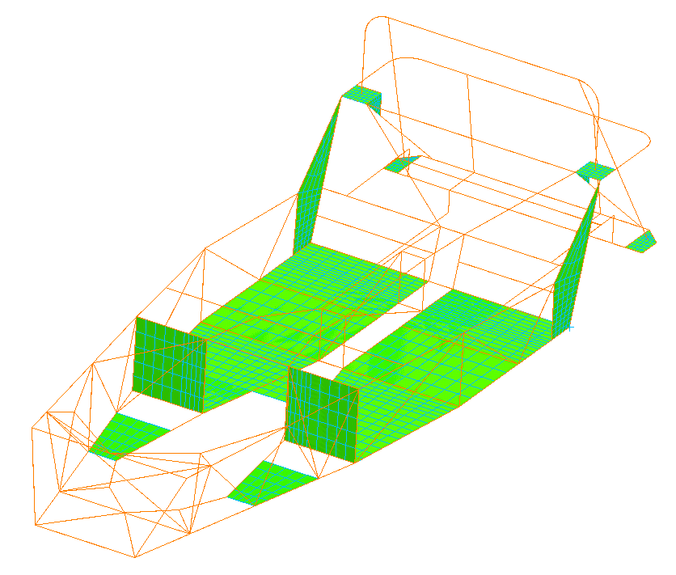

Triangulation

Fig. 47

Table 17
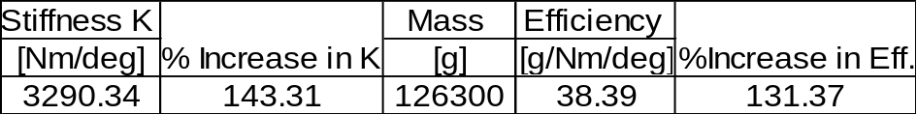

This modification helps to connect the upper and lower sections of the engine bay. It also triangulates the ring beam on the upper surface of the engine bay. Although it adds no significant stiffness, and in fact lowers the efficiency, it is believed it will enhance the effect of further modifications.

8.2.8 Further triangulation of the upper ring beam to the engine plates
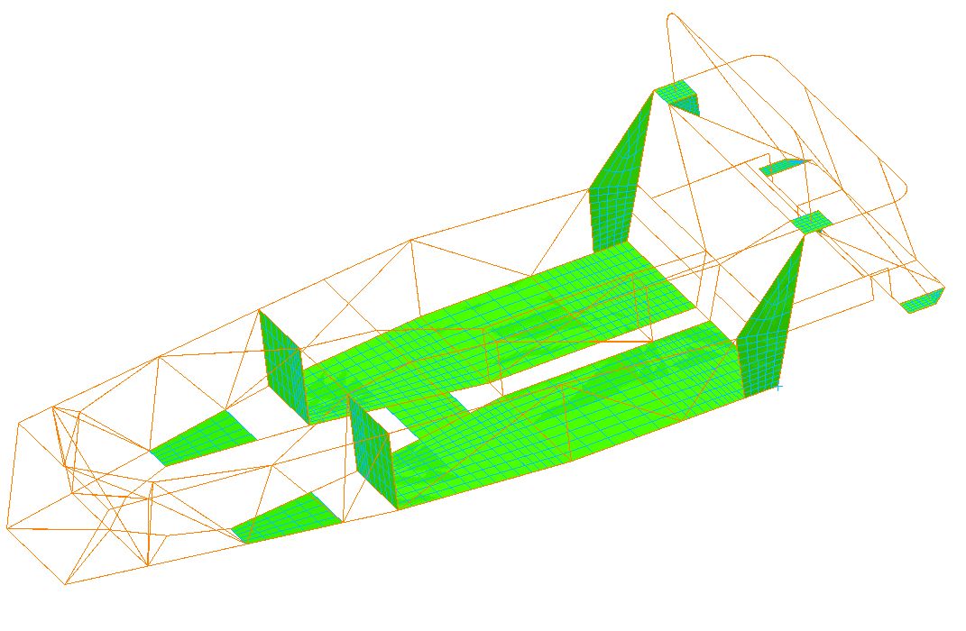

Triangulation

Fig. 48

Table 18
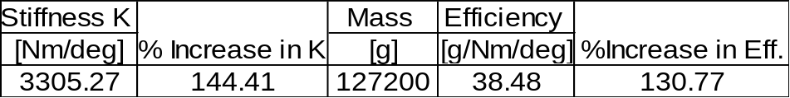

Again, it is believed that this modification will enhance the effect of further modifications rather than increasing torsional stiffness by its own doing.

8.2.9 Triangulation of the front face of the suspension box
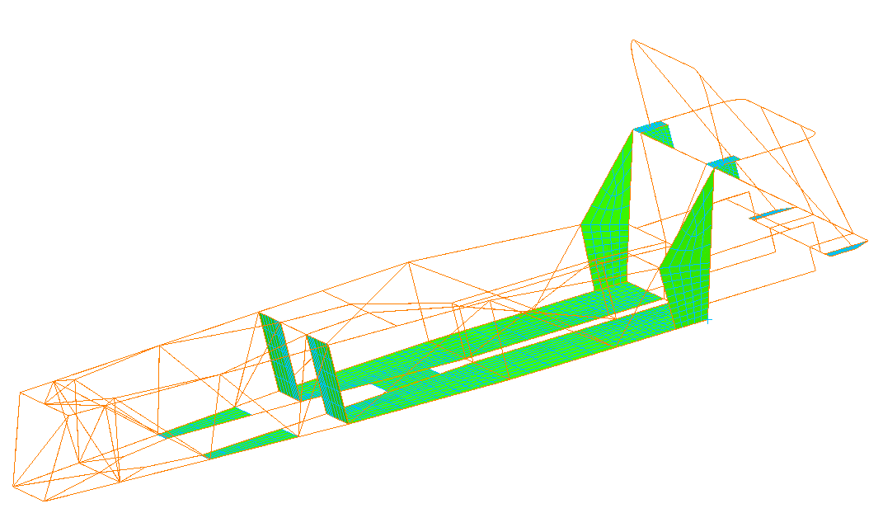
Triangulation

Fig. 49

Table 19
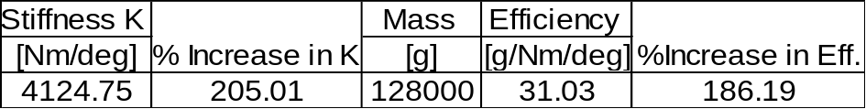

This modification shows that even with the previous stiffening of the suspension box the lack of lateral triangulation in this section was still paramount. It is believed that the stiffening of the suspension box has enhanced the effect the previous modifications will have on the torsional stiffness. This now provides triangulation to every face of the suspension box effectively turning it into a closed torsion box. With none of the beams in this section now placed in bending it shows a 60% increase in torsional stiffness over the previous model and a 205% increase over the original. This is reflected in the increase in efficiency of 56% over the previous model. Further triangulation for this area was considered however, the radiator is mounted to the front face of the suspension box and as much airflow is required through this face as possible. This prevented any further triangulation being added. The beam is 1” x 1” 16-gauge mild steel RHS.

8.2.10 Y-brace conversion of lower engine beam
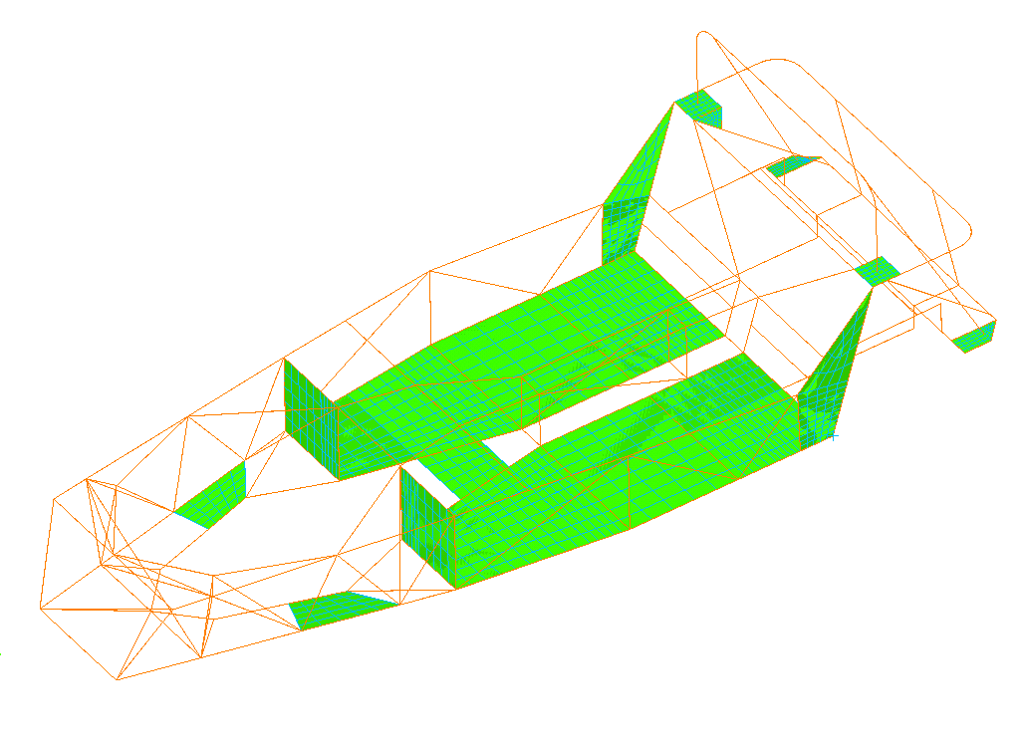
Y-brace

Fig. 50

Table 20
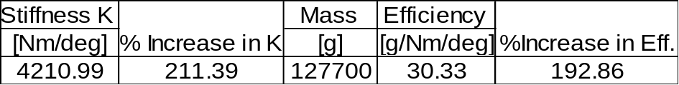

To optimise the efficiency of the outer rails, which, from analysis of the stress plots of the deformed model, were not highly stressed, the lower engine support beam was modified. This involved splitting the load paths from channelling the loads only into the transmission tunnel to channelling them into the outer rails as well. This was accomplished by changing the rear section of the engine support beam to a Y-brace. From the results in Table 20 where an increase in torsional stiffness and efficiency of 6% is shown over the previous model it can be seen that this modification is viable.

8.2.11 Conversion of 8mm flat bar to 2” x 1” RHS
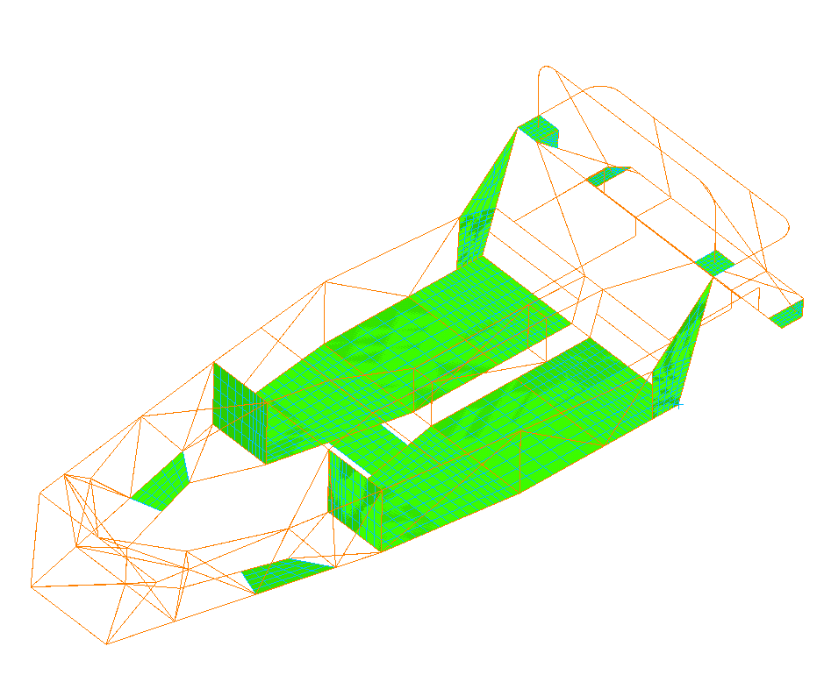

Fig. 51

Table 21
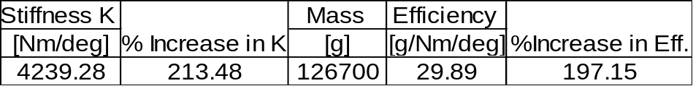

The upper triangulation on the rear firewall frame is of 8mm thick mild steel solid bar. This is approximately three times the mass of an equivalent section of 1” x 1” 16-gauge mild steel RHS and displays less torsional stiffness. Changing this to 2” x 1” 16-gauge mild steel RHS will not only reduce the mass but will also increase the torsional stiffness. This drop in mass and increase in torsional stiffness will inevitably lead to an increase in efficiency.

With an overall increase in torsional stiffness of 213% and an overall increase in efficiency of 197%, it is clear that the inclusion of all these modifications is viable.

8.3 Stage 3-Identical Modifications to Fully Panelled Chassis

The modifications as performed in 8.2 were performed on the fully panelled chassis to show the contribution to torsional stiffness provided by the shear panels. This also allowed an optimisation for mass as the panels could be changed from mild steel to aluminium and the effect on the stiffness of the modified chassis noted.

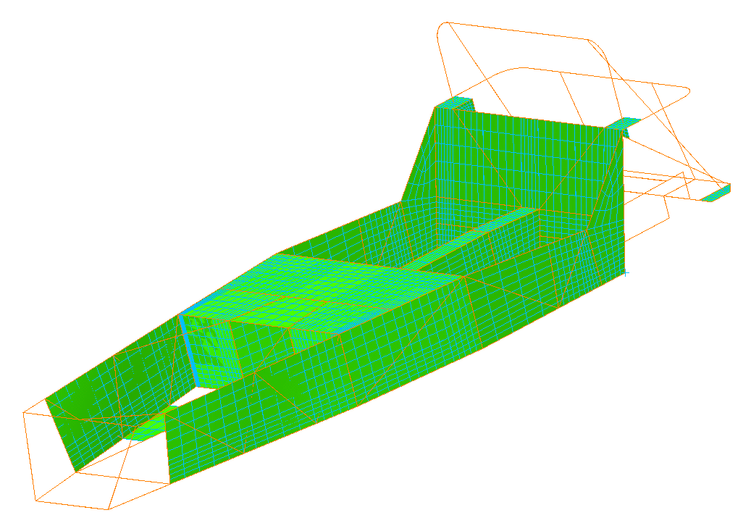

Fig. 52

Due to the panels partially obscuring the modifications (Fig.52) and their presence in 8.2, these results will be in a tabular form with no pictures of the chassis. The modifications were performed in the same order and are denoted by the notation 8.3.*.

Table 22
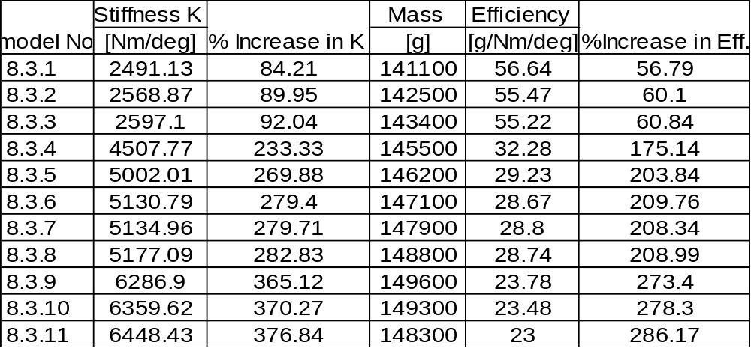

As can be seen in Table 22 when the modifications are performed on the fully panelled chassis from 8.1.9 the increase in torsional stiffness is almost 1000Nm/deg more than the sum of the individual improvements. This is due to the stiffening of the most flexible spring allowing a much greater improvement in the effectiveness of the stiffening of the passenger compartment. With an overall increase in torsional stiffness of 377% over the original chassis, these modifications show major improvement in the performance of the chassis. With an overall increase in efficiency of 286% over the original chassis, it can be assumed that more of the chassis is being used effectively to resist torsional loading

8.4 Stage 4-Optimisation Study

Now that a significant increase in torsional stiffness has been achieved, an optimisation study can be performed. This involves keeping the stiffness as high as possible but removing as much mass as possible. This can be achieved by conversion of mild steel panels to aluminium, by reduction in section size of beams that are not highly stressed or conversely increasing the section size of highly stressed beams. The optimisation has been aimed at achieving a minimum of 6000Nm/deg torsional stiffness with the minimum mass. It should be remembered at this stage that the baseline validation model was measured by the software as being 8Kg heavier than the original chassis. This means that the efficiency of the chassis will be even higher than the results suggest if a physical chassis with these modifications were to be constructed and it matched the predicted stiffness values. This is unlikely however and the efficiency is more likely to be as predicted due to the drop in mass and torsional stiffness that a physical chassis would have.

8.4.1 Conversion of 5mm thick bar to 2” x 1” RHS
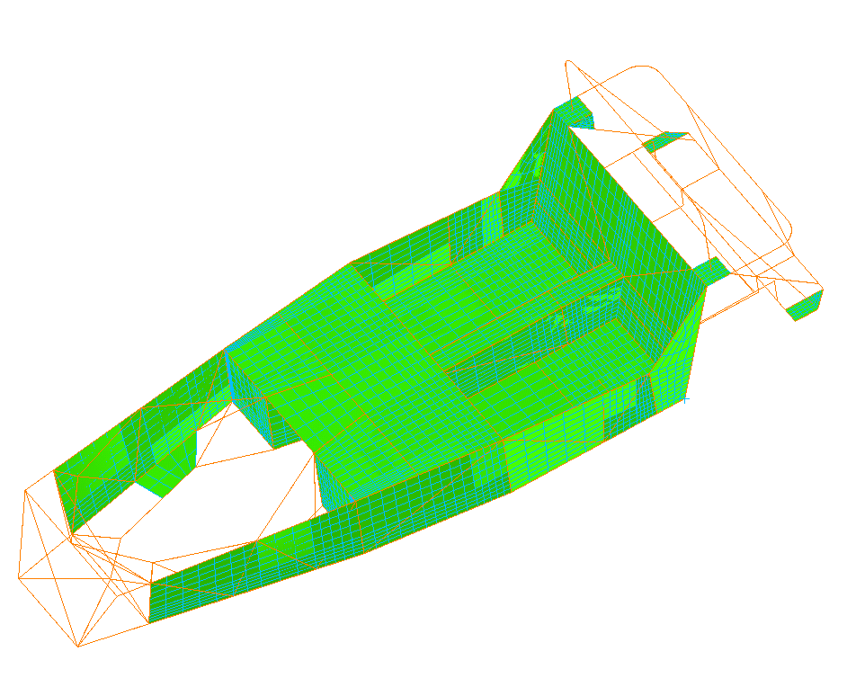

Fig. 53

Table 23
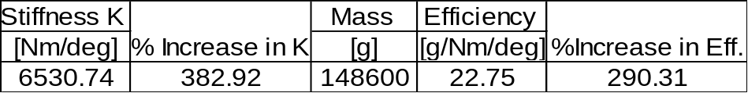

The conversion of the 5mm thick bar to 2” x 1” RHS raises the mass by 300g but this is offset by the rise in torsional stiffness and efficiency.

8.4.2 Conversion of mild steel floor to aluminium
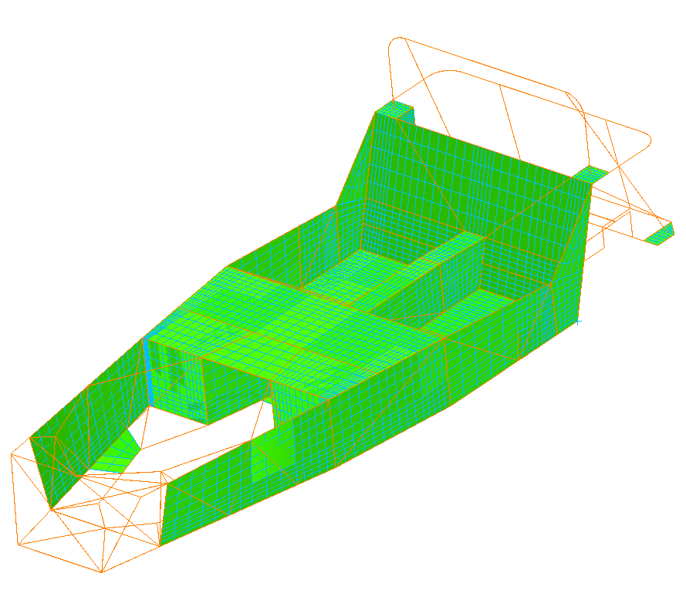

Fig. 54

Table 24
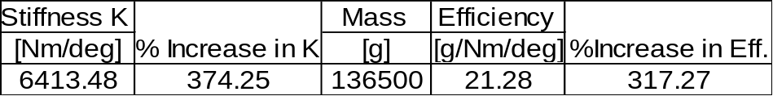

The conversion of the 16-gauge mild steel floor to 16-gauge aluminium drops the torsional stiffness by 6% in comparison to the previous model. However, the efficiency rises by 27%, more than offsetting drop in stiffness. As stated the aim of the optimisation was to keep the torsional stiffness above 6000Nm/deg whilst minimising the mass and optimising the efficiency. This modification has clearly been successful in realising this aim.

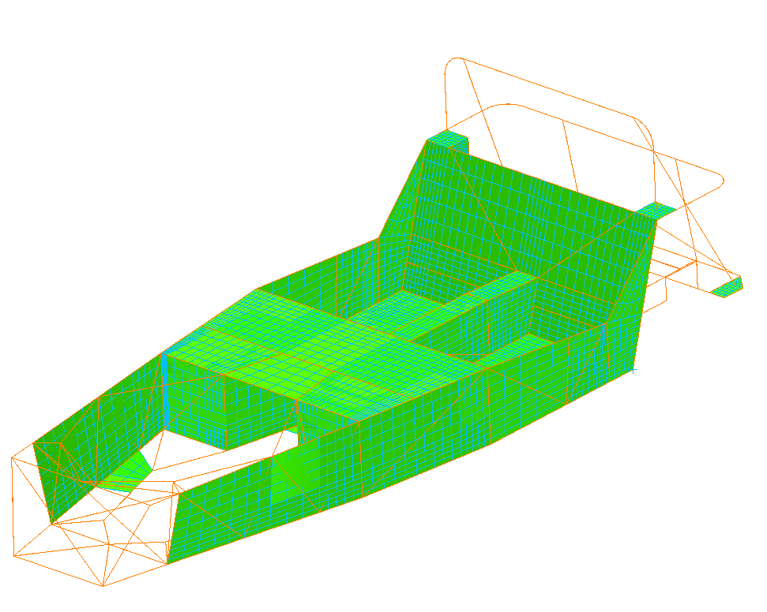
8.4.3 Conversion of mild steel transmission tunnel panels to aluminium

Fig. 55

Table 25
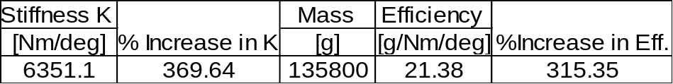

Conversion of Transmission Tunnel Entrance Beams to 1” x 1” RHS

Table 26
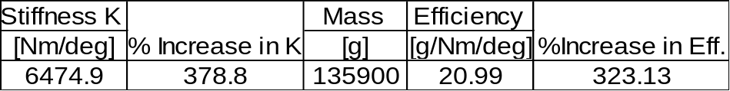

These beams were found to have high stress levels. By increasing their section size from ¾” to 1” RHS the stress levels dropped to within acceptable levels. The increase in mass of only 900g for their addition was acceptable in this optimisation study due to the increases in both torsional stiffness and efficiency of 9% and 7% respectively.

Conversion of Aluminium panels from 1.6mm to 1mm Thickness

Table 27
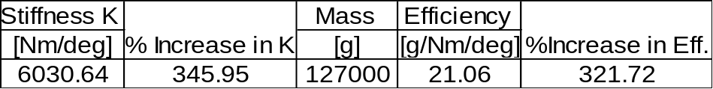

With the increases in torsional stiffness brought about by modifying the bare frame the thickness of the aluminium panelling could be adjusted to save mass. As shown in Table 27, by changing the panels to 1mm thick a mass saving of 8.9Kg was realised. This involved a marginal drop in efficiency with a corresponding drop in torsional stiffness that does not bring the value below the 6000Nm/deg limit of this optimisation study.

Other attempts at optimisation were developed in Patran however persistent and prolonged problems with the Nastran Server meant these were unable to be fully solved. One attempt was run and the result dropped the stiffness value below the 6000Nm/deg limit. It is believed the un-run models would have the same effect.
8.5 Rollcage Study

Although Luego have no current plans to develop a race version of the chassis a very basic rollcage study was performed (out of personal interest). This rollcage is shown below in Figs. 56, 57 & 58. This rollcage was added to model 8.2.11.
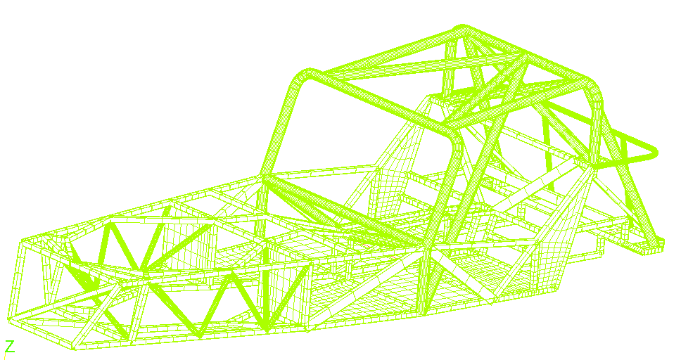

Fig. 56
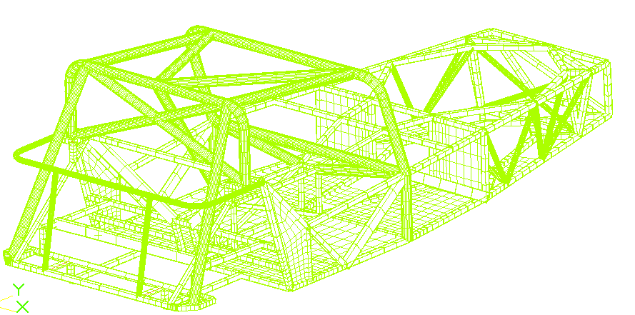

Fig. 57

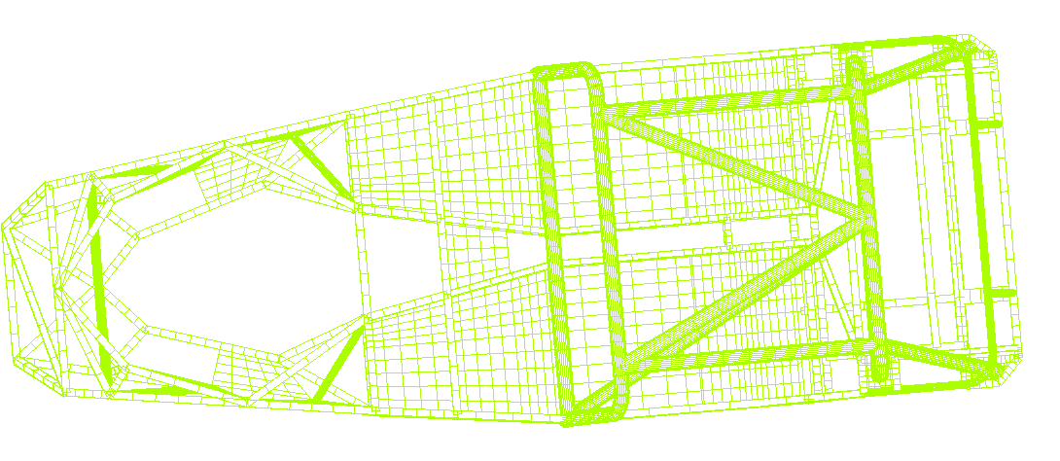

Fig. 58

Table 28
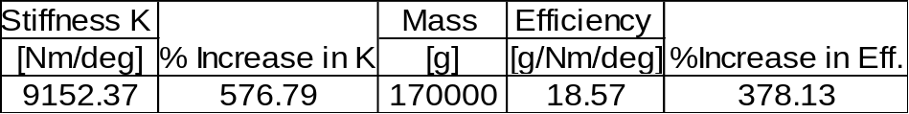

The rollcage closes the open section left by the passenger compartment and effectively forms a fully closed torsion box. As can be seen from Table 28 a massive increase in torsional stiffness can be achieved with a rollcage. This design does not attempt to be the optimum for a rollcage structure but is merely to show how closing the passenger compartment affects the torsional stiffness.

9 Conclusions

The purpose of this thesis was to:
- Perform a torsion test on the prototype chassis to determine its torsional stiffness
- Create a finite element model of the chassis
- Incorporate a design improvement study and note the effects on the global torsional stiffness
- To attempt an optimisation for maximum efficiency.

9.1 Physical Testing

The physical testing supplied an empirical value of global torsional stiffness for the prototype chassis. This gave a basis with which to validate the results of the Finite Element baseline model. By using only the restraints necessary to satisfy all six equilibrium equations, an accurate and viable value was achieved. This value of 1330Nm/deg was slightly unexpected as a similar but somewhat smaller and stiffer looking chassis recorded a lower value of stiffness.

9.2 Creation of FE baseline model

The FE baseline model created represented the chassis as accurately as possible within the constraints necessary for ‘line’ modelling in Patran/Nastran. Once all modelling corrections were completed, the baseline model was complete. The value for the torsional stiffness of this model was slightly higher than that resulting from physical testing. This was expected due to the infinite joint stiffness and small geometrical differences inherent in the model. The torsional stiffness value of 1352Nm/deg resulting from the analysis of this model was accepted as a substantial base from which to incorporate design improvements.

9.3 Design Improvement Study

Discussed Modifications

These modifications and panel modelling showed how the ‘cosmetic’ covering panels and some minor modifications in fact increase the torsional stiffness by up to 128%.
The basic panelling of the passenger compartment contributing up to 85% by acting as shear panels on untriangulated areas, with the addition of the dash bar and dash panelling contributing the remainder. The effect of converting the mild steel panels to aluminium showed the benefits achievable in mass reduction while still offering up to 81% more torsional stiffness and up to 54% more efficiency over the baseline model.

9.3.2 Applications of Structures Theory to Bare Chassis

By applying the theory of stiffening the most flexible spring in the chassis-spring series, major improvements in torsional stiffness were achieved. This involved concentrating design improvements on the front suspension box and engine bay. Through methodical triangulation and reinforcement of open sections with ring beams, these flexible springs were made increasingly stiff.
These design improvements were realised with a 213% increase in torsional stiffness over the baseline model. With the improvements to load path distribution, by re-directing some of the loading through the passenger compartment side rails, complimenting the design improvements an increase in efficiency of 197% was realised over the baseline model.

9.3.3 Inclusion of Design Improvements to Fully Panelled Chassis

When the design improvements were combined with fully panelling the chassis, the results were quite dramatic. An increase in torsional stiffness of up to 377% over the baseline model were realised along with an increase in efficiency of up to 286%. This shows that the improvements compliment each other to give a stiffness of almost 1000Nm/deg more than the sum of the individual improvements.

Optimisation Study

With the torsional stiffness increased sufficiently the optimisation study aimed to keep the stiffness over 6000Nm/deg whilst minimising mass and maximising efficiency. An optimum combination will be a compromise as are most areas of design of a sports car. The optimum was reached in model 8.4.4 with a torsional stiffness of 6474.9Nm/deg, an increase of 378% over the baseline model. A mass of 135.9Kg for the fully panelled chassis was achieved with an efficiency of 20.99g/Nm/deg, an increase of 323% over the baseline model.

References

- Forbes, Aird. (1997). Race Car Chassis, Design and Construction. MBI Publishing Company, Wisconsin, USA.

- Brown, J.C. (2002). Structural Design for Motorsport. Lecture Notes, Cranfield University.

- Pawlowski, J. (1969). Vehicle Body Engineering. Business Books, London.

- Brown, J.C., Robertson, A.J. and Serpents, S.J. (2002). Motor Vehicle Structures: Concepts and Fundamentals. Butterworth-Heinemann, Oxford.

- Champion, Ron. (2000). Build Your Own Sports Car for as Little as £250-and Race It!, 2nd ed. Haynes Publishing, Somerset.

- MSC/NASTRAN Quick Reference Guide. (1998). MacNeal-Schwendler Corporation.

- www.daxcars.co.uk. Company Information Website. Accessed 24th July 2002.

- www.caterhamcars.co.uk. Company Information Website. Accessed 2nd August 2002.

- www.westfield.co.uk. Company Information Website. Accessed 2nd August 2002.

- www.quantumcars.co.uk. . Company Information Website. Accessed 4th August 2002.

- www.robinhoodengineering.co.uk. Company Information Website. Accessed 7th August 2002.

